Hosting a Static Website on Amazon S3
Services Used:
Amazon S3: To store the required files which are required for the static website.
Also, we need an AWS account to access and the basic HTML and CSS for designing the website as a prerequisite.
IAM: Identity and access management to manage the permissions and public access.
Difference between Static Website and a Dynamic Website:
In static, it is used HTML, CSS, JavaScript but when dynamic it needs a server, database, and also the scripting languages like php, python etc.
In static, changes need to be made manually but in dynamic they can be managed via database or any management system.
Static websites need a basic server or can be created even using a storage service but dynamic needs a web server along with the backend support.
Steps followed:
1) Login to the AWS Management Console.
Created a S3 bucket.
We must enter a unique bucket name.
I left all the settings as default and created a bucket.
2) Once the bucket is created,
I have created a required HTML file for the website and saved.
I also downloaded some jpg images from the google for my website where I used their path in the HTML code.
Once all files are created, I uploaded all the files and images in the bucket.
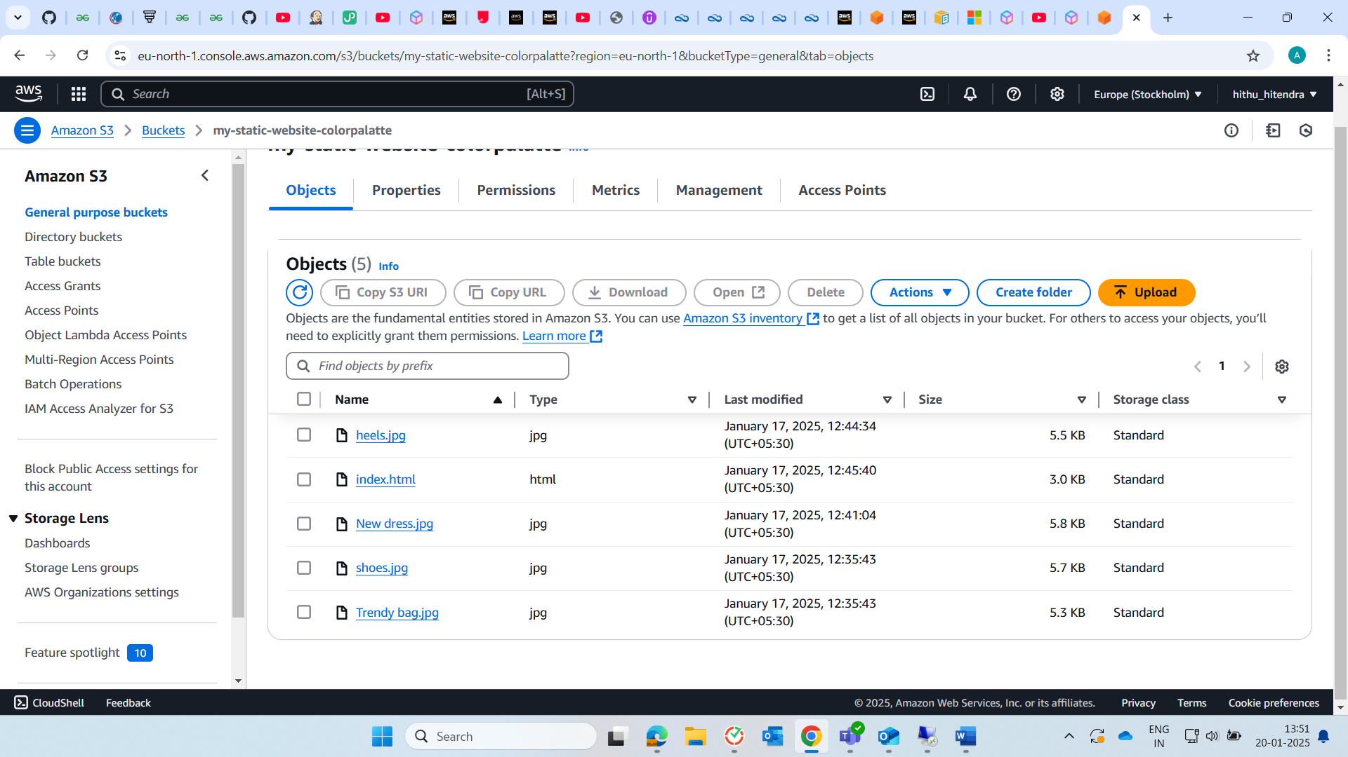
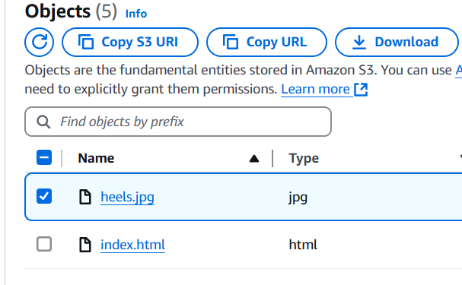

I have copied the URL of the image from here and pasted the same URL in the html code.
3) We must enable static website Hosting.
open the properties tab and scroll to static website hosting.
we have to edit and enable it. Change the index document to index.html.
set error.html as it is as it is optional and then save the changes.

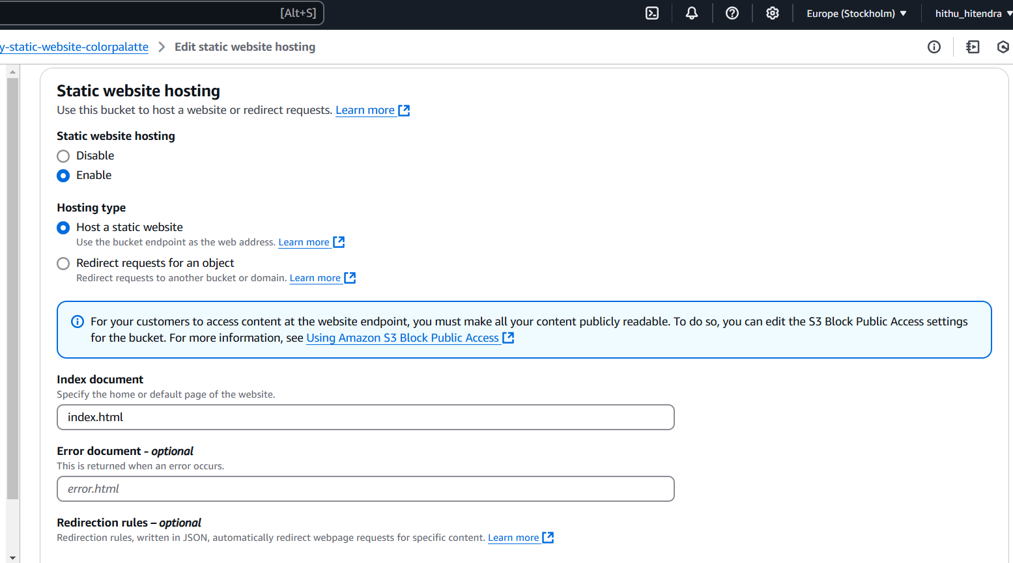

4) Bucket Policy:
In the permission tab we go to bucket policy and change the policy there.
A bucket policy is a Json based access control policy which we attached to a bucket. Usually, policy defines the permissions for actions we perform on the bucket. It defines who can access, what actions they can perform, and under what conditions they can.
{
"Version": "2012-10-17",
"Statement": [
{
"Sid": "StaticHostingPolicy",
"Effect": "Allow",
"Principal": {
"AWS": "*"
},
"Action": "s3:GetObject",
"Resource": "arn:aws:s3:::my-static-website-colorpalatte/*"
}
]
}

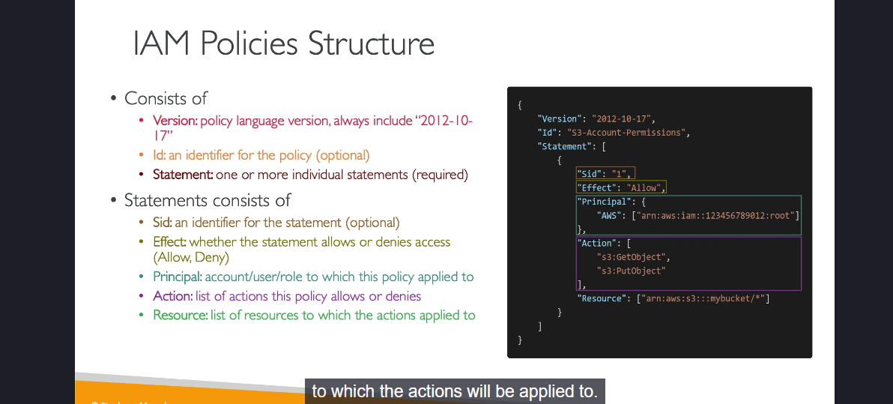

5) To test our static website, we have to go to properties and copy the bucket website endpoint.
We have to paste the endpoint URL into the web browser.
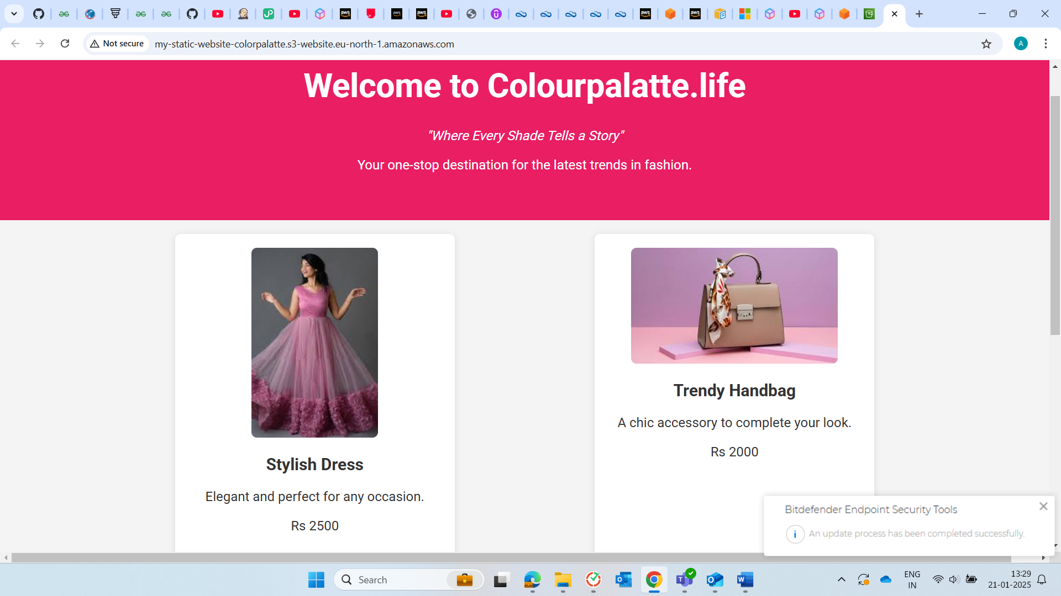

HTML Code:
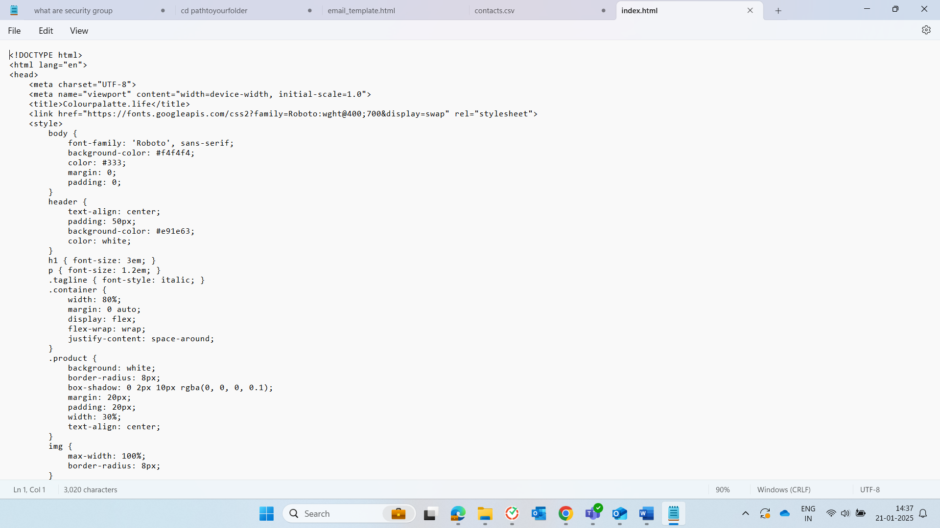
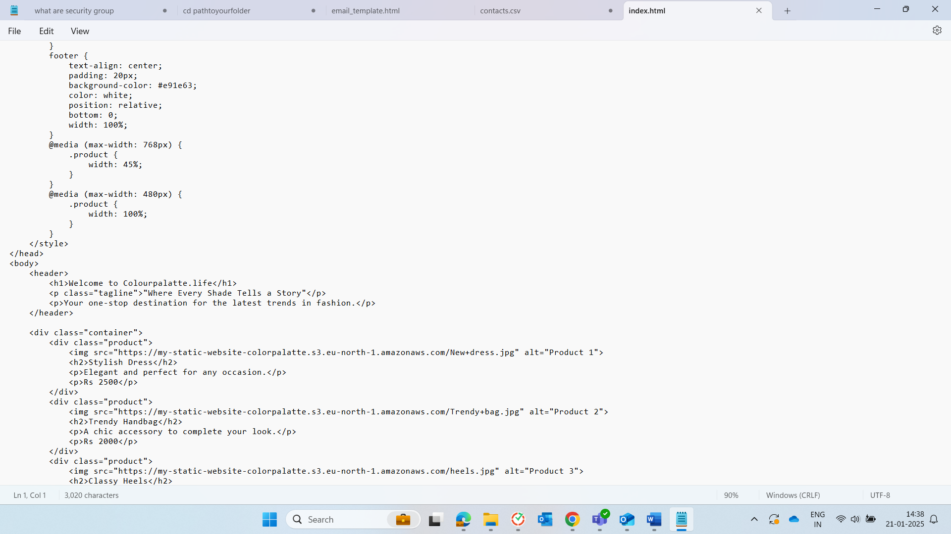
<p>Comfort meets style with these Classy Heels.</p>
<p>Rs 3500</p>
</div>
</div>
<footer>
<p>&copy; 2024 Colourpalatte.life. All Rights Reserved.</p>
</footer>
</body>
</html>
EOF

Learnings:
We can directly put the content without requiring the web server with the help of Amazon S3 as we are creating a static website.
We have to look clearly on the public access settings and bucket policy which is the key for the website to access for the users.
S3 can host only static content website like HTML, CSS. For dynamic functionality we need to integrate with other services.
Mainly we can host a website using S3 for temporary events, portfolios, a demo sites, Single page applications, personal blogs with the regular updates etc.

